**Practical 5**

Miqdad Rajkotwala, 50

**Aim : Write a Matlab program using linear Equation**

% Define the coefficient matrix A and the right-hand side vector b

A = [2, 3; 1, -1];

b = [8; 1];

% Solve the linear equation Ax = b using linsolve

x_numerical = linsolve(A, b);

% Display the numerical solution

disp('Numerical Solution:');

disp(x_numerical);

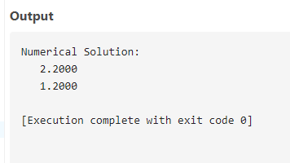

% Define the coefficient matrix A and the right-hand side vector b

A = [2, 3; 1, -1];

b = [8; 1];

% Solve the linear equation Ax = b using the backslash operator

x_numerical = A \ b;

% Display the numerical solution

disp('Numerical Solution:');

disp(x_numerical);

